Nepal College of Information Technology

**Unit Test**

Spring 2013

Program : BE ELX Time : 2 hrs

Semester : (VI) FM : 70

Subject : Filter Design PM : 35

* *Candidates are requested to give their answer as far as practicable in their own words.*
* *The figure in the margin indicates the full marks*
* *Attempt ALL question*
* *Assume suitable data if necessary*

1. a) Define scaling and derive the expression to determine the new value of circuit elements in frequency, magnitude and both frequency and magnitude scaling. [2+6]

b) What is the importance of frequency transformation in filter design? Find the band pass filter network, assuming suitable low-pass prototype network by using frequency transformation. [2+5]

2. a) Explain the Inverse Chebyshev approximation for low pass filter and derive an expression for the order (n) of the filter. [4+3]

b) Consider a filter with Butterworth response with the following specifications:

Passband attenuation: 0.5 dB

Stopband attenuation: 20 dB

Passband edge frequency: 1000 rad/sec

Stopband edge frequency: 2000 rad/sec

Determine the order of the filter, half-power frequency and network function. [3+2+3]

3. a) Realize the third order Butterworth lowpass filter for the singly terminated arrangement as shown below: [7]

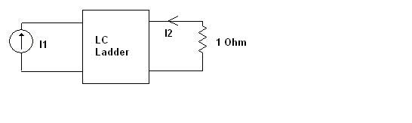

b) Obtain a transfer function for Butterworth high pass filter with following specification.[8]

αmax= 3 dB, αmin= 40 dB

fp= 1 MHz, fs=200 KHz

4. a) Design a fifth-order LC filter having a maximally flat passband with αmax=0.7 dB in f≤fp=460 KHz. Source and load resistors are 50 Ω. [8]

b) We require a Chebyshev lowpass filter to satisfy following specifications. The loss in the passband to 10KHz is to be 0.3 dB or less, and beyond 24.58 KHz the loss is to be at least 22 dB. Find the minimum order , half-power frequency for such low-pass filter. [7]

5. Write short notes on: ( Any Two) [2*5]

a) Insertion gain and Insertion loss

b) Delay equalization

c) Properties of Butterworth filter